PRAYERS OF REPARATION
TO THE HOLY FACE OF JESUS,

as requested by Our Lord Jesus Christ. These prayers are to be said on Sundays and Holy Days of Obligation, publicly (if possible), and preferably before the Blessed Sacrament or before the picture of the Holy Face.

Dear Lord, through the Sorrowful and Immaculate Heart of Mary, I (we) offer Thee these prayers in reparation for the sins which offend God the most in these modern times – the sins of BLASPHEMY and the PROFANATION OF SUNDAY and Thy Holy Days of Obligation:

One Our Father, Hail Mary, and Glory Be To The Father

THE “GOLDEN ARROW” PRAYER
Dictated by Our Lord to Sister Mary of St. Peter

May the most holy, most sacred, most adorable, most incomprehensible and unutterable Name of God be always praised, blessed, loved, adored and glorified in Heaven, on earth, and under the earth, by all the creatures of God, and by the Sacred Heart of Our Lord Jesus Christ in the Most Holy Sacrament of the Altar. Amen.

After receiving this prayer, Sister Mary of St. Peter was given a vision in which she saw the Sacred Heart of Jesus delightfully wounded by this “Golden Arrow”, as torrents of graces streamed from It for the conversion of sinners.

LITANY OF THE HOLY FACE OF JESUS

I salute Thee, I adore Thee and I love Thee, O adorable Face of Jesus, my Beloved, noble Seal of the Divinity! outraged anew by blasphemers. I offer Thee, through the heart of Thy blessed Mother, the worship of all the Angels and Saints, most humbly beseeching Thee to repair and renew in me and in all men Thine Image disfigured by sin.
O adorable Face which was adored, with profound respect, by Mary and Joseph when they saw Thee for the first time, have mercy on us.
O adorable Face which ravished with joy, in the stable of Bethlehem, the Angels, the shepherds and the magi, have mercy…
O adorable Face which transpierced with a dart of love in the Temple, the saintly old man Simeon and the prophetess Anna, have mercy…
O adorable Face which filled with admiration the Doctors of the Law when Thou appeared in the Temple at the age of twelve years, have mercy…
O adorable Face which possesses beauty always ancient and always new, have mercy…
O adorable Face which is the masterpiece of the Holy Ghost, in which the Eternal Father is well pleased, have mercy…
O adorable Face which is the ineffable mirror of the divine perfections, have mercy…

Adorable Face of Jesus which was so mercifully bowed down on the Cross, on the day of Thy Passion, for the salvation of the world! Once more today in pity bend down towards us poor sinners. Cast upon us a glance of compassion and give us Thy peace.

O adorable Face which became brilliant like the sun and radiant with glory, on the Mountain of Thabor, have mercy…
O adorable Face which wept and was troubled at the tomb of Lazarus, have mercy…
O adorable Face which was rendered sad at the sight of Jerusalem, and shed tears on that ungrateful city, have mercy…
O adorable Face which was bowed down to the ground in the Garden of Olives, and covered with confusion for our sins, have mercy…
O adorable Face which was covered with the sweat of blood, have mercy…
O adorable Face which was struck by a vile servant, covered with a veil of shame, and profaned by the sacrilegious hands of Thine enemies, have mercy…
O adorable Face which by Its divine glance, wounded the heart of St. Peter with a dart of sorrow and love, have mercy…
Be merciful to us, O my God! Do not reject our prayers, when in the midst of our afflictions, we call upon Thy Holy Name and seek with love and confidence Thine adorable Face.

O adorable Face which was washed and anointed by Mary and the holy women and covered with a shroud, have mercy…
O adorable Face which was all resplendent with glory and beauty on the day of the Resurrection, have mercy…
O adorable Face which is hidden in the Eucharist, have mercy…
O adorable Face which will appear at the end of time in the clouds with great power and great majesty, have mercy…
O adorable Face which will make sinners tremble, have mercy…
O adorable Face which will fill the just with joy for all eternity, have mercy…
O adorable Face which merits all our reverence, our homage and our adoration, have mercy…
O Lord, show us Thy Face, and we shall be saved!
O Lord, show us Thy Face, and we shall be saved!
O Lord, show us Thy Face, and we shall be saved!

PRAYER TO OFFER THE HOLY FACE OF JESUS TO GOD THE FATHER TO APPEASE HIS JUSTICE AND DRAW DOWN MERCY UPON US

Almighty and Eternal Father, since it has pleased Our Divine Savior to reveal to mankind in modern times the power residing in His Holy Face, we now avail ourselves of this Treasure in our great need. Since Our Savior Himself promised that by offering to Thee His Holy Face disfigured in the Passion we can procure the settlement of all the affairs of our household, and that nothing will be refused to us, we now come before Thy throne.
Eternal Father, turn away Thine angry gaze from our guilty people whose face has become unsightly in Thine eyes. Look instead upon the Face of Thy Beloved Son; for this is the Face of Him in whom Thou art well pleased. We now offer Thee His Holy Face covered with blood, sweat, dust, spittle and shame, in reparation for the worst crimes of our age, which are atheism, blasphemy, and the desecration of Thy holy days. We thus hope to appease Thine anger justly provoked against us. The All-Merciful Advocate opens His mouth to plead our cause; listen to His cries, behold His tears, O God, and through the merits of His Holy Face hearken to Him when He intercedes for us poor miserable sinners.

“Rejoice, My daughter, because the hour approaches when the most beautiful work under the sun will be born.”
- Our Lord to Sister Mary of St. Peter

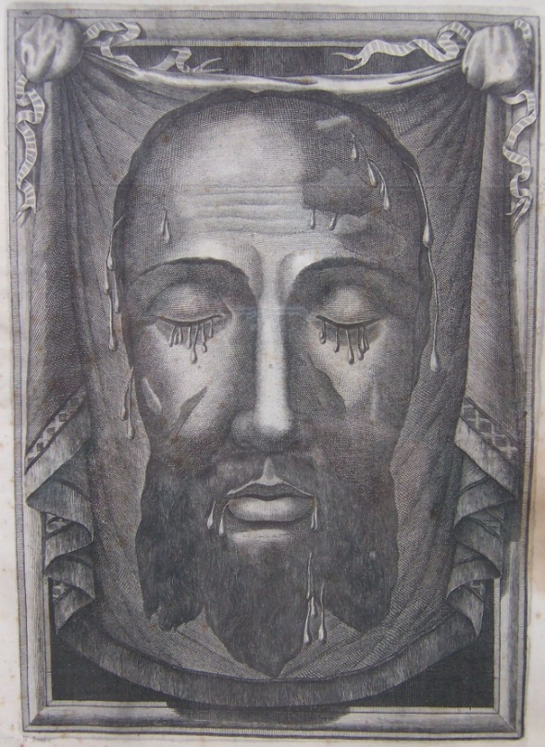
THE HOLY FACE OF JESUS
A copy of the miraculous image on Veronica’s veil.
(The actual veil is kept in St. Peter’s Basilica, Rome.)
PROMISES OF OUR LORD JESUS CHRIST

To Sr. Mary of St. Peter, Carmelite Nun of Tours, France, in favor of those who honor His Holy Face.
- By offering My Face to My Eternal Father, nothing will be refused, and the conversion of many sinners will be obtained.
- By My Holy Face, they will work wonders, appease the anger of God and draw down mercy on sinners.
- All those who honor My Face in a spirit of reparation will by so doing perform the office of the pious Veronica.
- According to the care they take in making reparation to My Face, disfigured by blasphemers, so will I take care of their souls which have been disfigured by sin. My Face is the Seal of the Divinity, which has the virtue of reproducing in souls the image of God.

- Those who by words, prayers or writing defend My cause in the Work of Reparation, especially My priests, I will defend before My Father, and will give them My Kingdom.

- As in a kingdom they can procure all that is desired with a coin stamped with the King’s effigy, so in the Kingdom of Heaven they will obtain all they desire with the precious coin of My Holy Face.

- Those who on earth contemplate the wounds of My Face shall in Heaven behold it radiant with glory.

- They will receive in their souls a bright and constant irradiation of My Divinity, that by their likeness to My Face they shall shine with particular splendor in Heaven.

- I will defend them, I will preserve them and I assure them of Final Perseverance.

FURTHER REVELATIONS FROM OUR DIVINE LORD CONCERNING REPARATION TO HIS HOLY FACE, as told to Sister Mary of St. Peter

- …It is the express will of God that this devotion be established in every diocese; that it be most zealously propagated; and granted a papal brief so that it will never perish.
- …This devotion is to have the TWOFOLD PURPOSE OF REPARATION FOR BLASPHEMY and REPARATION FOR THE PROFANATION OF SUNDAY and Holy Days of Obligation, the two principal sins which in modern times are provoking the anger of God. Sr. Mary said, “He then made me see that this frightful sin wounds His Divine Heart more grievously than all other sins, showing me how by BLASPHEMY the sinner curses Him to His Face, attacks Him publicly, nullifies His Redemption, and pronounces his own judgment and condemnation…The Savior made me understand that His justice was greatly irritated against mankind for its sins but particularly for those that directly outrage the Majesty of God – that is, Communism, Atheism, cursing, and the desecration of Sundays and the Holy Days. He said, “The executioners crucified me on Friday, CHRISTIANS CRUCIFY ME ON SUNDAY”.
…THIS ASSOCIATION IS TO BE CALLED “DEFENDERS OF THE HOLY NAME OF GOD”.

- …Each day, in a spirit of REPARATION, members are to say one Our Father, Hail Mary, Glory Be To The Father, and the “Golden Arrow” prayer. On Sundays and Holy Days of Obligation ALL the prayers of reparation are to be said.
- …Members must refrain from work on Sundays themselves, and do what is in their power to see that others stop all unnecessary servile work on the holy days of the Lord.
- …Members should wear a special cross with the words “Blessed be the Name of God”, on one side, and “Begone Satan!” on the reverse, which gives a special resourcefulness to conquer the demon of blasphemy.
- …Every time one hears a curse he should repeat the two short inscriptions on each side of the cross, and he will thus overcome the evil one, and render glory to God.
- …The association is to be placed under the patronage of Saints: Michael, Joseph, Martin of Tours, Louis, Veronica, and Teresa of Avila.
- …Our Lord desires that His Holy Face be offered as the exterior object of adoration to all His children who would be associated with this work of Reparation. His Holy Face is the very Image of God. “Offer It unceasingly to My Father for the salvation of your country”.
- …”The treasure of My Holy Face in itself possesses such tremendous value that through It ALL the affairs of My household can readily be settled.”
- …”If you knew how pleasing the sight of My Face is to My Father.”
- …This was an early revelation from heaven concerning Communism. Our Lord said that this devotion would defeat it. It is, therefore, the sister-devotion to the Fatima devotion – necessary to save the world. (There are many knowledgeable people who say that the present “collapse” of Communism is a deception, and that these devotions are needed now more than ever before.)
- …Our Lord told Sr. Mary, “Woe to those cities that will not make this Reparation!”
- …He said, “Sinners are snatched from this world and they are swept into hell like the dust that is carried away by the fury of a tornado. Have pity on your brothers and pray for them!”
- …One can make a NOVENA OF REPARATION TO OBTAIN A FAVOR by saying the “Golden Arrow” prayer and “The Litany of the Holy Face” on nine consecutive days, preferably before the Blessed Sacrament or the picture of the Holy Face, and by going to Confession and Holy Communion.
These revelations and more are to be found in THE GOLDEN ARROW (Tan Books, Box 424, Rockford, IL 61105 or www.tanbooks.com). “This book is based upon and quoting authentic French manuscripts emanating directly from the archives of the Monastery of Discalced Carmelites, Tours, France, where Sister Mary of St. Peter lived and died in the odor of sanctity.” (In the absence of a formal association in a parish, individuals should say the prayers and follow Our Lord’s directives as best they can.)

OUR LORD’S REVELATIONS WERE FOLLOWED BY 30 YEARS OF MIRACLES attesting to the truth and power of this devotion. In 1885 Pope Leo XIII, by papal brief, established this devotion as an archconfraternity; and contrary to custom, immediately established it FOR THE ENTIRE WORLD. It was universally practiced until a few years before World War I. THE NEGLECT OF THIS DEVOTION AND OF OUR LADY’S REQUESTS AT FATIMA IN 1917, ESPECIALLY THE DAILY ROSARY, was followed by two world wars, the murder and enslavement of billions of people by Communism, and an unprecedented increase in sin and loss of the faith. This pamphlet has been printed in an attempt to revive this extremely important devotion, which Christ wants to last until the end of time.
This was also the favorite devotion of St. Theresa of the Child Jesus and of the Holy Face. She has said that the suffering, wounded Face of her dear Jesus was the foundation of all her piety. At the age of twelve, St. Theresa and her whole family registered as members of the Archconfraternity of Reparation to the Holy Face in Tours, France. Pope St. Pius X called St. Theresa “The greatest Saint of modern times”.
FOR THOSE WHO WOULD LIKE TO DO MORE An ejaculation to be frequently recited during the day:

ETERNAL FATHER, I offer Thee the Holy Face of Jesus, covered with blood, sweat, dust and spittle, in reparation for the crimes of communists, blasphemers, and for the profaners of the Holy Name and of the Holy Day of Sunday.

A CHAPLET OF REPARATION was given by Our Lord to Sr. Mary of St. Peter to battle against the enemies of God, especially communists.
* On the Crucifix say: Eternal Father I offer Thee the cross of Our Lord Jesus Christ and all the other instruments of His Holy Passion, that Thou may put division in the camp of Thine enemies; for as Thy Beloved Son has said, “A kingdom divided against itself shall fall.”

* On the next five beads say:
1) May God arise and let His enemies be scattered and let those who hate Him flee before His Face!
2) May the thrice Holy Name of God overthrow all their plans!
3) May the Holy Name of the Living God split them up by disagreements!
4) May the terrible Name of the God of Eternity stamp out all of their godlessness!
5) Lord, I do not desire the death of the sinner, but that he be converted and live. “Father, forgive them for they know not what they do.”

* On the medal say: the “Golden Arrow” prayer.

* On the thirty three white beads say: Arise, O Lord, and let Thine enemies be scattered, and let those that hate Thee flee before Thy Face.

* On each of the six large beads say: “My Jesus, mercy” and one “Glory Be”.

* On the medal at the end say: the ejaculation above, and the following is recommended; “O Mary conceived without sin, Patroness of the United States of America, pray for us who have recourse to Thee.”

FOR A FREE BLESSED CHAPLET and other inquiries contact:
Immaculate Heart of Mary Apostolate, PO Box 2407, Milford, CT 06460
www.holyfacedevotion.com
(With Ecclesiastical Approval)

